Monika George Bash lab 2

Q1

[monikageorge00@localhost ~]$ vi hello.sh

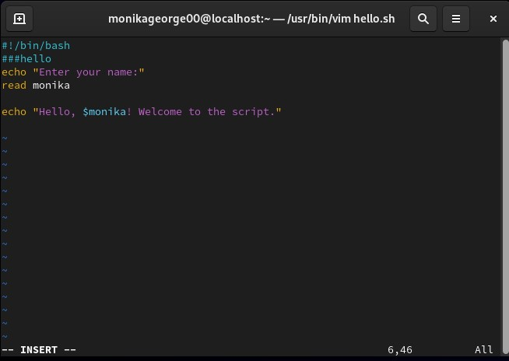

Q2

S1

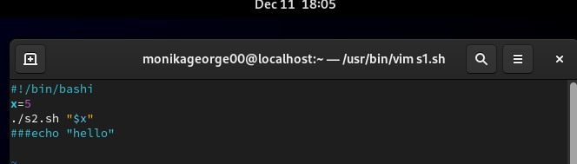

S2

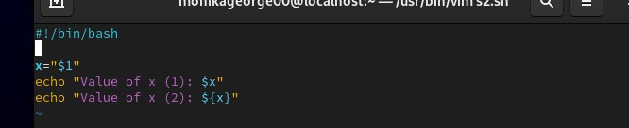

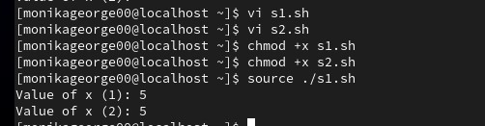

Q3

[monikageorge00@localhost ~]$ vi mycp.sh s1.sh s2.sh

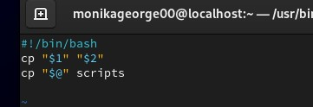

Q4

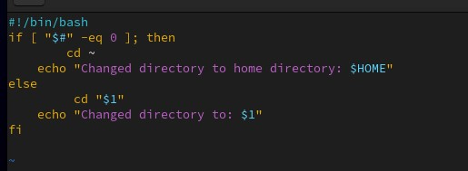

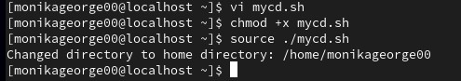

Q5

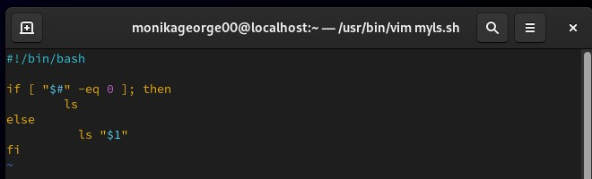

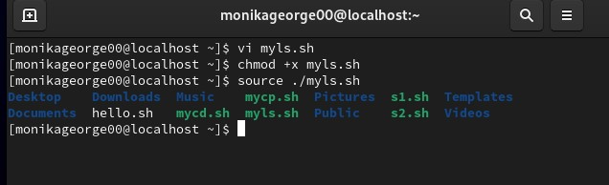

Q6

